**CHAPTER1**

**INTRODUCTION**

**1.1 BRIEF OVERVIEW**

A music reactive LED cube project involves constructing a cube-shaped structure outfitted with LEDs that respond to audio input. Typically, the LEDs change colors, patterns, or brightness based on the sound or music playing nearby. This project integrates electronics, microcontrollers (such as Arduino or Raspberry Pi), and programming to create a visually dynamic display synchronized with audio cues. It's a popular choice for DIY electronics enthusiasts and often serves as interactive art installation or a decorative item that enhances the ambiance of a space.- Importance of music-reactive lighting systems.

**1.2 OBJECTIVES** :

Objectives of a music reactive LED cube project can typically include:

1. Interactive Visual Display: Create a visually engaging display that responds to music or sound inputs in real-time.

2. Learning Electronics and Programming: Provide a hands-on opportunity to learn about microcontrollers (e.g., Arduino), sensors, and programming languages (e.g., C/C++).

3. Enhancing Ambiance: Serve as a decorative item or interactive art piece that enhances the atmosphere of a room or event.

4. Creative Expression: Encourage creativity in designing LED patterns, colors, and responses that synchronize with different types of music.

5. Educational Tool: Act as an educational tool to understand concepts like analog-to-digital conversion, signal processing, and real-time data manipulation.

6. Community Sharing: Facilitate sharing of ideas and designs within the DIY electronics community, often through online forums and platforms.

7. Skill Development: Develop skills in soldering, circuit design, and troubleshooting electronic components.

Overall, the project aims to combine technical skills with artistic expression to create a responsive and visually captivating LED display synchronized with music.

List of specific goals for the project

**1.3 COMPONENTS USED**

Building a music-reactive LED cube involves several components to achieve the desired functionality. Here's a detailed list of components typically used for such a project:

1. LED controller IC LM3914

2. LEDs:

WS2812B or similar individually addressable LEDs: These are RGB LEDs that can be controlled independently, allowing for complex patterns and effects.

3. Power Supply:

Depending on the size of the cube and the number of LEDs, a 5V power supply with sufficient current capacity (usually calculated based on the number of LEDs and their power consumption).

4. Audio Input Module:

Electret Microphone or Audio Input Module: This captures the sound/music input which the cube will react to. Alternatively, an FFT (Fast Fourier Transform) module can be used for more precise frequency analysis.

5. Amplifier (optional):

If using an Electret Microphone, an amplifier circuit might be necessary to boost the signal to a usable level for the microcontroller.

6. Level Shifter (if using 5V LEDs with 3.3V microcontroller):

Logic level shifter to interface between the 3.3V microcontroller and the 5V LEDs, ensuring proper communication without damaging components.

7. Wiring and Connectors:

Dupont wires, breadboard or PCB for connections, and headers for easy interfacing and prototyping.

8. Enclosure or Frame:Depending on your design, you might need a frame or enclosure to hold the LEDs in the shape of a cube.

9. Miscellaneous:

Resistors: Depending on your circuit design, you might need resistors for current limiting or voltage dividers.

Capacitors: For decoupling and stabilizing power supply.

Heat sinks (if needed): For components that might get hot during operation.

**1.4 Optional Enhancements**:

Bluetooth Module: For wireless control or audio streaming.

SD Card Module: To store audio patterns or configurations.

Real-time Clock Module: For time-based effects or synchronization.

**1.5 TOOLS REQUIRED**

Soldering iron and solder.

Multimeter for testing voltages and continuity.

**1.6 Considerations**:

Power Consumption: LEDs can draw significant current, so ensure your power supply can handle the load.

Heat Management: LEDs and some electronic components may generate heat, necessitating ventilation or heat sinks.

Safety: Working with electrical components requires attention to safety protocols, such as avoiding shorts and ensuring proper insulation.

**CHAPTER 2**

**METHODOLOGY:**

Schematic diagram of the LED cube circuit

**2.1 Explanation of each component’s role**

How the LEDs are arranged in the cube structure

LM3914 IC is an integrated circuit (IC) designed to function as a linear voltage level meter or LED driver. Here are some key points about the LM3914:

1. Functionality: It can drive up to 10 LEDs in a bar-graph display mode or a single LED in a dot mode based on an analog voltage input.

2. Voltage Range: Typically operates over a range of 0V to 12V, but it can handle higher voltages with additional components.

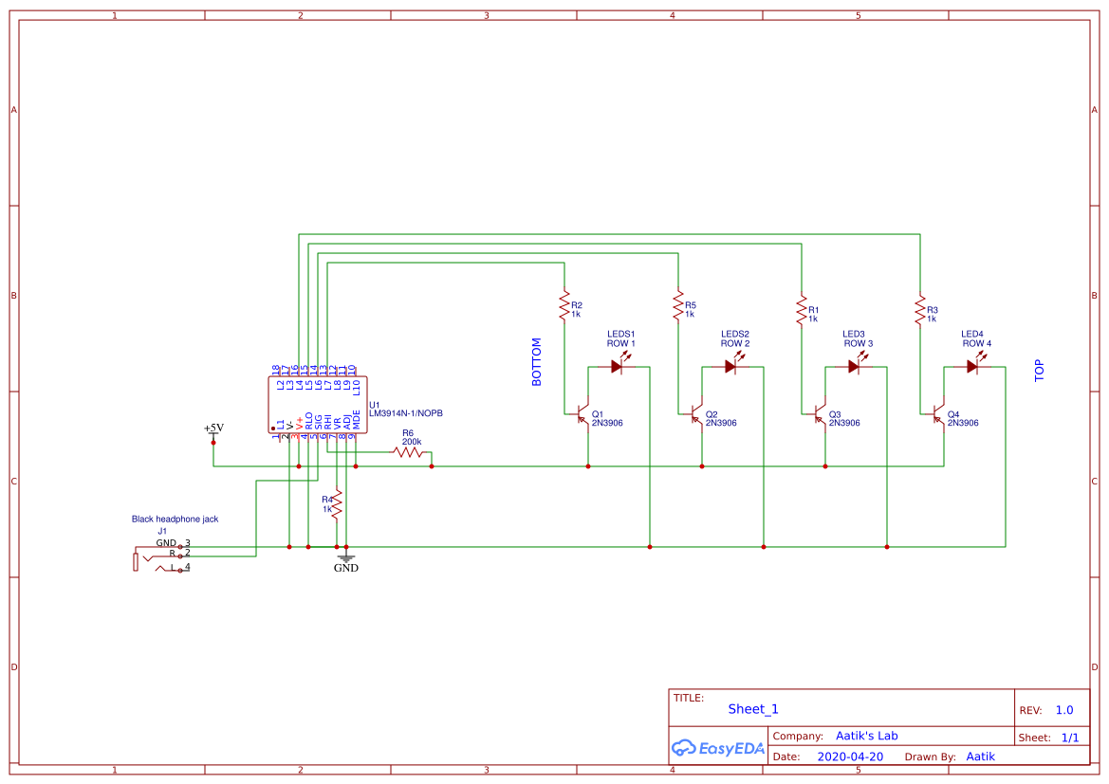**2.2 CIRCUIT DESIGN:**

Fig-2.2 :circuit diagram of music reactive LED cube

3. LED Display Modes:

Bar Mode: The LEDs light up in a sequence, resembling a bar graph, with each LED corresponding to a specific voltage level range.

Dot Mode: Only one LED lights up at a time, indicating the exact voltage level.

4. Pin Configuration: It has pins for power supply (V+, V-), reference voltage (REF), voltage input (VI), and output pins to connect LEDs.

5. Internal Circuitry: Internally, it includes a voltage reference, a precision voltage divider, comparators, and a resistor ladder network to drive LEDs.

6. Applications: Commonly used in audio level indicators, VU meters, battery level indicators, and any application where visual representation of voltage levels is needed.

7. Advantages: It simplifies the design of LED-based voltage meters or displays, eliminating the need for complex analog circuits.

8. Variants: There are different versions of the LM3914, such as the LM3915 and LM3916, which offer expanded features like logarithmic scaling, higher LED counts, and different voltage ranges.

Overall, the LM3914 is widely used due to its ease of use, versatility in applications, and reliability in providing visual indication of voltage levels using LEDs.5. Implementation

Step-by-step description of the construction process

Challenges faced during assembly and how they were overcome

**2.3 TRANSISTOR 2N3906**

The 2N3906 is a widely-used PNP bipolar junction transistor (BJT) typically used for general-purpose amplification and switching applications. Here are the key details about the 2N3906 transistor:

1. Type: It is a PNP transistor, which means it is designed to operate with negative polarity on the base relative to the emitter (as opposed to NPN transistors which operate with positive polarity).

2. Pin Configuration: The 2N3906 transistor has three pins:

Emitter (E): This is where the current flows out of the transistor.

Base (B): This controls the current flow between the emitter and collector.

Collector (C): This is where the current flows into the transistor.

3. Electrical Characteristics:

Maximum Ratings: These include parameters such as maximum collector-base voltage (V_CBO), maximum collector-emitter voltage (V_CEO), maximum emitter-base voltage (V_EBO), maximum collector current (I_C), and maximum power dissipation (P_TOT).

Current Gain (hFE): This parameter indicates the amplification ability of the transistor. For the 2N3906, typical values of current gain (hFE) range from 100 to 300.

4. Applications:

Amplification: Used in audio amplifiers, voltage amplifiers, and other signal amplification circuits.

Switching: Can be used as a low-power switch in circuits where moderate switching speeds are sufficient.

Voltage Regulation: It can be used in voltage regulators and current mirrors.

5. Package Type: The 2N3906 transistor is available in various package types, including TO-92 (the most common), SOT-23, and others. The TO-92 package is a small plastic package with three leads (pins).

6. Operating Conditions: Typically operates within a range of voltages and currents suitable for low-power applications. The specific operating conditions depend on the circuit design and application requirements.

In summary, the 2N3906 transistor is valued for its versatility in both amplification and switching applications, making it a popular choice among hobbyists and professionals alike for various electronic projects

**2.4 LED**

The term "LED" stands for Light Emitting Diode. It's a semiconductor device that emits light when an electric current passes through it. LEDs are widely used in various applications such as lighting, displays (like those on TVs and smartphones), indicators, and even in automotive lighting. They are known for their energy efficiency, durability, and compact size compared to traditional light sources like incandescent bulbs or fluorescent tubes. LED technology has advanced significantly, offering a wide range of colors, brightness levels, and applications across different industries..

**2.5 HEADPHONE JACK**

A headphone jack, also known simply as a jack or audio jack, is a standard socket found on various electronic devices, primarily for connecting headphones or earphones. It allows audio signals to be transferred from the device to headphones, enabling the user to listen to audio privately without using external speakers.

Headphone jacks come in different sizes, the most common being 3.5mm (also known as 1/8 inch) and 6.35mm (1/4 inch) in diameter. The smaller 3.5mm jack is typically found on smartphones, tablets, laptops, and smaller audio devices, while the larger 6.35mm jack is more common on professional audio equipment like amplifiers, musical instruments, and high-end headphones.

The headphone jack functions by providing a connection that carries both audio signals (left and right stereo channels) and sometimes a microphone signal for devices that support hands-free calling or voice commands. When headphones are plugged into the jack, it often automatically switches the audio output from the device's built-in speakers to the headphones, allowing for private listening.

Recently, some devices, particularly smartphones, have started to omit the headphone jack in favor of wireless Bluetooth headphones or USB-C connectivity, which can transmit audio signals digitally.

**2.6 RESISTORS**

Resistors are fundamental electronic components that resist the flow of electric current. They are designed to introduce a specific amount of resistance into an electrical circuit. This resistance is measured in ohms (Ω).

**2.7 Purpose and Function:**

1. Limiting Current: Resistors are primarily used to limit the amount of current flowing through a circuit. This is crucial to protect sensitive components from damage due to excessive current.

2. Voltage Division: They are also used in voltage dividers, where they help in creating a specific voltage output from a higher voltage source by forming a voltage divider network with other resistors.

3. Adjusting Signal Levels: In analog circuits, resistors can adjust signal levels, set bias points, and determine gain in amplifiers.

**2.8 Types of Resistors:**

1. Fixed Resistors: These have a specific resistance value that cannot be adjusted. They come in various packages and types, such as carbon film, metal film, and wirewound resistors.

2. Variable Resistors (Potentiometers): These resistors have an adjustable resistance value that can be manually changed using a knob or slider. They are often used for volume controls, tuning circuits, and calibration.

3. Thermistors: These resistors change resistance with temperature variations, making them useful in temperature sensing applications.

**2.9 Color Code:**

Fixed resistors are typically color-coded to indicate their resistance value and tolerance. The colors on the resistor's body correspond to specific digits and a multiplier, following a standardized color code.

**2.10 Applications:**

Resistors are essential in virtually all electronic circuits, from simple LED circuits to complex microprocessor-based systems. They play critical roles in controlling current flow, setting voltage levels, ensuring stability, and matching impedances.

In summary, resistors are indispensable components in electronics, offering precise control over electrical currents and voltages in a wide range of applications.

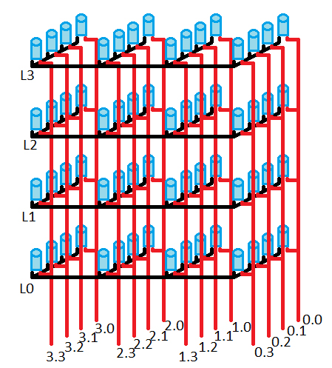**2.11 LED CUBE ARRANGEMENTS**

Fig-2.11 :4*4*4 LED cube

**2.12 MUSIC ANALYSIS AND CONTROL**

In a music reactive LED cube project, "music" refers to the audio input signal, typically from a microphone or audio source, that drives the behavior of the LEDs in the cube. The "analysis control" aspect involves processing this audio input to extract meaningful information that can be used to control the LEDs in sync with the music. Here’s how these components typically work together:

1.Audio Input (Music):The project starts with capturing audio input. This can be done using a microphone placed near speakers playing music, or directly from an audio source such as a computer or smartphone.

2. Signal Processing:The audio signal is processed to analyze its characteristics. Common techniques include:

Frequency Analysis: Breaking down the audio signal into different frequency bands (bass, midrange, treble).

Amplitude Analysis: Determining the intensity or loudness of the audio signal.

Beat Detection: Identifying the rhythm or beat of the music.

1. Control of LEDs:
2. Based on the analysis of the audio signal, specific parameters are extracted. These parameters are then used to control the LEDs in the cube.

For example:

Bass Response: LEDs might pulse or change color based on the bass frequencies detected in the music.

Beat Sync: LEDs could flash or change patterns in time with the beat of the music.

3. Spectrum Analysis: LEDs might light up different sections of the cube based on the frequency content of the music.

4. Implementation: Microcontrollers or digital signal processors (DSPs) are commonly used to perform the signal processing and control the LEDs. They receive the audio input, process it in real-time, and then send commands to the LEDs to create the desired visual effects.

5. Visual Effects: The LEDs in the cube respond dynamically to changes in the music, creating an immersive visual experience that complements the audio.

The design of these effects can vary widely based on the complexity of the signal processing algorithms and the capabilities of the LED cube.

Overall, the music reactive LED cube project combines audio signal processing techniques with LED control to create a synchronized visual display that enhances the music listening experience. The key is in accurately analyzing the music in real-time and translating that analysis into expressive lighting patterns and effects on the LED cube.

**2.13 LED CONTROL AND VISUALIZATION**

In a music reactive LED cube project, "LED control and visualization" refer to how the LEDs within the cube are manipulated and visually represented in response to the music being played. Here’s a detailed explanation of these aspects:

**2.14 LED Control:**

1. Microcontroller or Processor: Typically, a microcontroller or digital signal processor (DSP) is used to control the LEDs. This device receives input from the audio signal processing stage and generates control signals for the LEDs based on analyzed music parameters.

2. Mapping to LEDs: LEDs are arranged in a 3-dimensional matrix within the cube. Each LED has a specific position (x, y, z coordinates) within this matrix, allowing for spatial effects and animations.

3. Effects and Patterns:

Color Changes: LEDs can change colors based on the frequency content of the music. For instance, bass frequencies might correspond to deep blue or red colors, while high frequencies could trigger bright white or green.

Intensity and Brightness: The amplitude of the audio signal can dictate the brightness or intensity of LEDs, creating dynamic lighting effects.

Animation: LEDs can animate in patterns such as pulsing, fading, strobing, or scrolling through different colors and intensities.

4. Synchronization:

LED control is synchronized with the music to create visually appealing effects that match the rhythm, tempo, and mood of the music.

Beat detection algorithms ensure that LEDs flash or change patterns in time with the music's beat, enhancing the immersive experience.

5. Real-Time Processing: LED control algorithms must operate in real-time to maintain synchronization with the audio signal, ensuring that visual effects are responsive and accurate.

**2.15 Visualization:**

1. Spatial Representation: LEDs are arranged in a 3D matrix, allowing for spatial effects where patterns and animations can move or propagate through different layers or sections of the cube.

This spatial arrangement enhances the visual impact, creating a sense of depth and dimensionality in the lighting effects.

2. Dynamic Effects:

Visual effects are dynamic and responsive to changes in the music. As different frequencies and rhythms are detected, corresponding LED patterns and colors change accordingly.

This dynamic nature ensures that the LED cube visualizes the energy and characteristics of the music in real-time.

3. User Interaction:

Some projects include user interaction features, such as buttons or sensors, that allow users to change LED patterns or effects manually.

This interactivity enhances the user experience by giving them control over the visual representation of the music.

4. Aesthetic Design:

Designing visually appealing LED patterns involves creativity in choosing colors, transitions, and animations that complement the music's mood and style.

Aesthetic considerations ensure that the LED cube not only reacts to the music but also enhances the overall ambiance of the environment.

**2.16 Implementation Considerations**:

Hardware: Choosing LEDs with appropriate brightness, color range, and controllability (such as addressable LEDs) is crucial for achieving desired visual effects.

Software: Developing efficient algorithms for LED control and visualization requires expertise in signal processing, real-time systems, and microcontroller programming.

**CHAPTER 3**

**RESULT AND DISCUSSION**

The result and testing phase of a music reactive LED cube project are crucial stages where the functionality, performance, and reliability of the system are evaluated. Here’s how this phase typically unfolds:



Fig-3.1:Soldering the LED’s

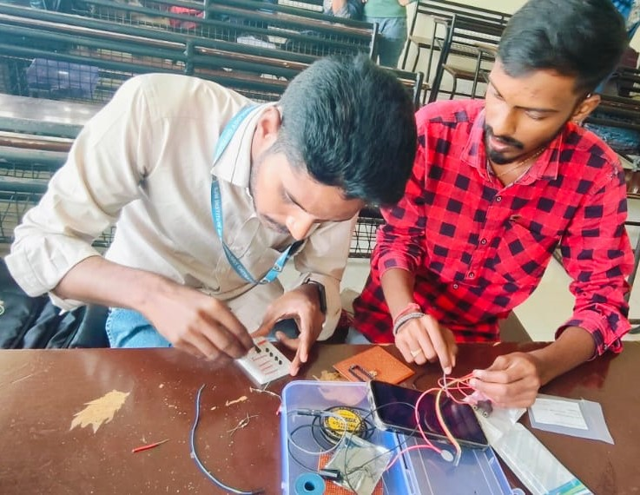

Fig-3.2:Making the circuit connection

**2.3 Result of the Project**:

1. Functionality Verification:

Ensure that the LED cube accurately responds to different types of music inputs, such as varying genres, tempos, and audio levels.

2. Performance Evaluation:

Assess the responsiveness of the LED cube. It should react promptly to changes in the music, maintaining synchronization without noticeable delays.

Check for smooth transitions between different LED patterns and animations, ensuring that the visual effects are visually appealing and enhance the music listening experience.

3. Accuracy of Signal Processing:

Validate the accuracy of signal processing algorithms used for frequency analysis, beat detection, and amplitude measurement.

Ensure that the extracted parameters (e.g., bass levels, beat timing) are correctly interpreted to control the LEDs effectively.

4. User Interaction Testing:

If the project includes user interaction features (such as manual control buttons or sensors), test their functionality and responsiveness.

Evaluate how effectively users can adjust LED patterns or effects to match their preferences or the mood of the music.

5. Reliability and Stability:

Run the LED cube for extended periods to assess its reliability. Ensure that it operates consistently without crashes, glitches, or unexpected behavior.

Test the system under different environmental conditions (e.g., ambient noise levels) to gauge its robustness and stability.

**2.4 Testing Procedures**:

1. Test Cases Development:

Create comprehensive test cases that cover various aspects of the project, including different music genres, tempo ranges, and intensity levels.

Include edge cases to evaluate how well the LED cube handles challenging audio inputs or unusual music patterns.

2. Real-World Testin:

Conduct testing in a real-world environment where the LED cube will be used. This includes testing with different music sources (e.g., live music, recorded tracks) and audio playback equipment.

3. Debugging and Optimization:

Identify and address any issues or bugs encountered during testing. This may involve debugging code, refining algorithms, or optimizing performance to enhance responsiveness and efficiency.

4. Feedback and Iteration:

Gather feedback from users and stakeholders to understand their experience with the LED cube.

Use feedback to iterate on the design, improve user interface (if applicable), and enhance overall usability and satisfaction.

**2.5 Documentation and Deployment**:

1. Documentation:
2. Document the testing results, including observations, issues encountered, and resolutions implemented.
3. Update documentation related to hardware setup, software configuration, and operational guidelines for future reference.
4. Deployment:Prepare the LED cube for deployment in its intended environment. This may involve packaging the hardware securely, ensuring all connections are stable, and providing user instructions for setup and operation

**CHAPTER4**

**4.1 CONCLUSION**

The music reactive LED cube project represents a captivating intersection of technology, art, and music, offering an immersive visual experience that enhances the auditory sensation of music. Here's a concise conclusion summarizing its key aspects and significance:

Key Aspects:

1. Audio Interaction: By analyzing the audio input in real-time, the LED cube dynamically responds to the music's rhythm, beat, and frequency content. This interaction creates synchronized lighting patterns and animations that visually interpret the music.

2. LED Control and Visualization: LEDs arranged in a 3-dimensional matrix are controlled to display vibrant colors, intricate patterns, and spatial effects. This visual representation not only mirrors the music's energy but also adds an aesthetic dimension to the listening experience.

3. Technological Integration: Utilizing microcontrollers or DSPs for signal processing, along with advanced algorithms for beat detection, frequency analysis, and LED animation, ensures precise synchronization and responsiveness to the audio input.

4. User Engagement: Incorporating user interaction features allows for customization and control over LED patterns, enhancing user engagement and personalization of the visual effects.

5. Creative Expression: Designing aesthetically pleasing LED animations involves artistic creativity in choosing colors, transitions, and patterns that harmonize with the music, thus transforming the environment into a dynamic visual spectacle.

**4.2 Significance:**

Enhanced Entertainment: The project elevates the entertainment value of music by providing a multisensory experience where sound and light converge to create an immersive atmosphere.

Educational Value: It serves as a practical application of electronics, programming, and signal processing concepts, making it a valuable educational tool for learning about technology and art integration.

Artistic Expression: Artists and enthusiasts can explore creative expression through the manipulation of light and color in response to music, fostering innovative approaches to visual arts and interactive installations.

**4.3 Future Directions**:

Advanced Features: Incorporating machine learning for more sophisticated music analysis, integrating wireless connectivity for remote control, or enhancing LED resolution and density for richer visual effects.

Community Engagement: Sharing designs, code, and experiences with the maker community to foster collaboration, innovation, and continual improvement in music-reactive LED projects.

In conclusion, the music reactive LED cube project merges technology and creativity to transform musical experiences into visual spectacles. It not only entertains and engages but also inspires exploration at the intersection of art, technology, and human expression.